Lab – 3 – I have one webserver in Mumbai region where my website in running and I need same server in Singapore region and migrate it from Mumbai to Singapore.

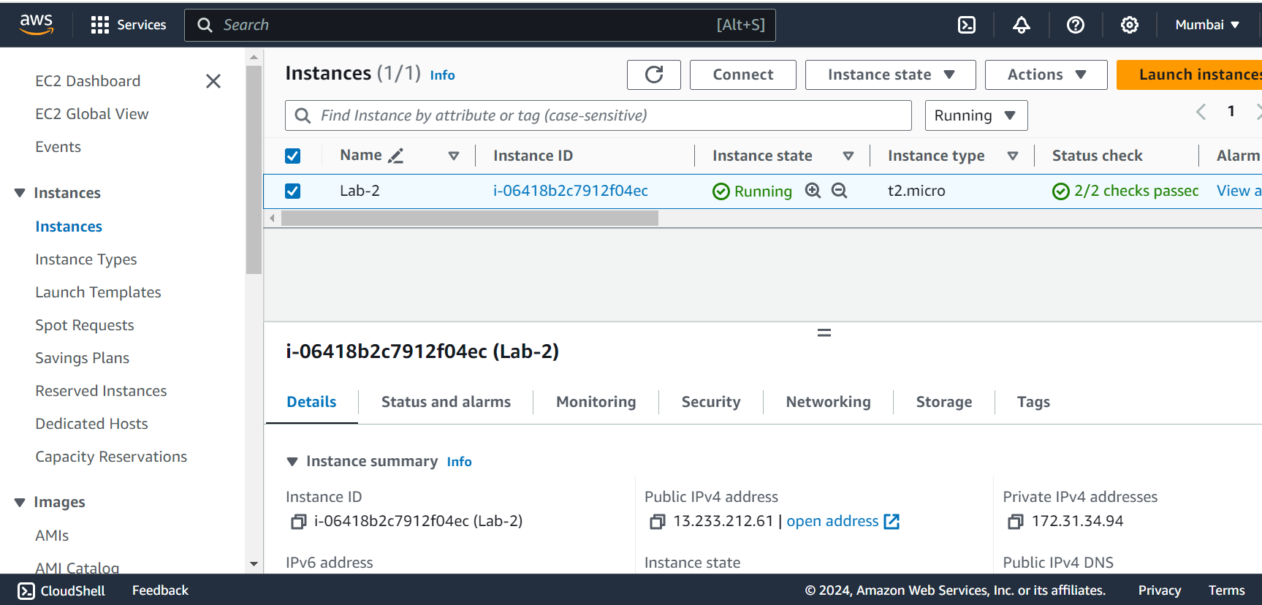

Here instance is live.

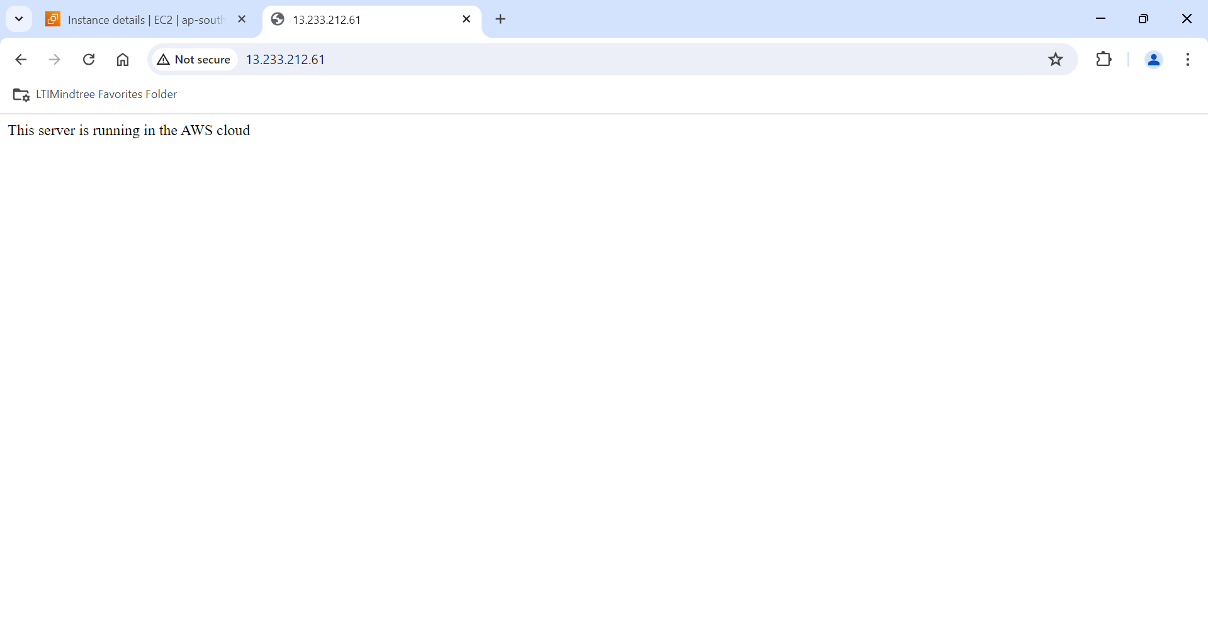

Webserver is running live on Mumbai Server.

An AMI has been created for the ec2 instance.

Now we will copy AMI in the Singapore region.

AMI has been created for instance in the Singapore region.

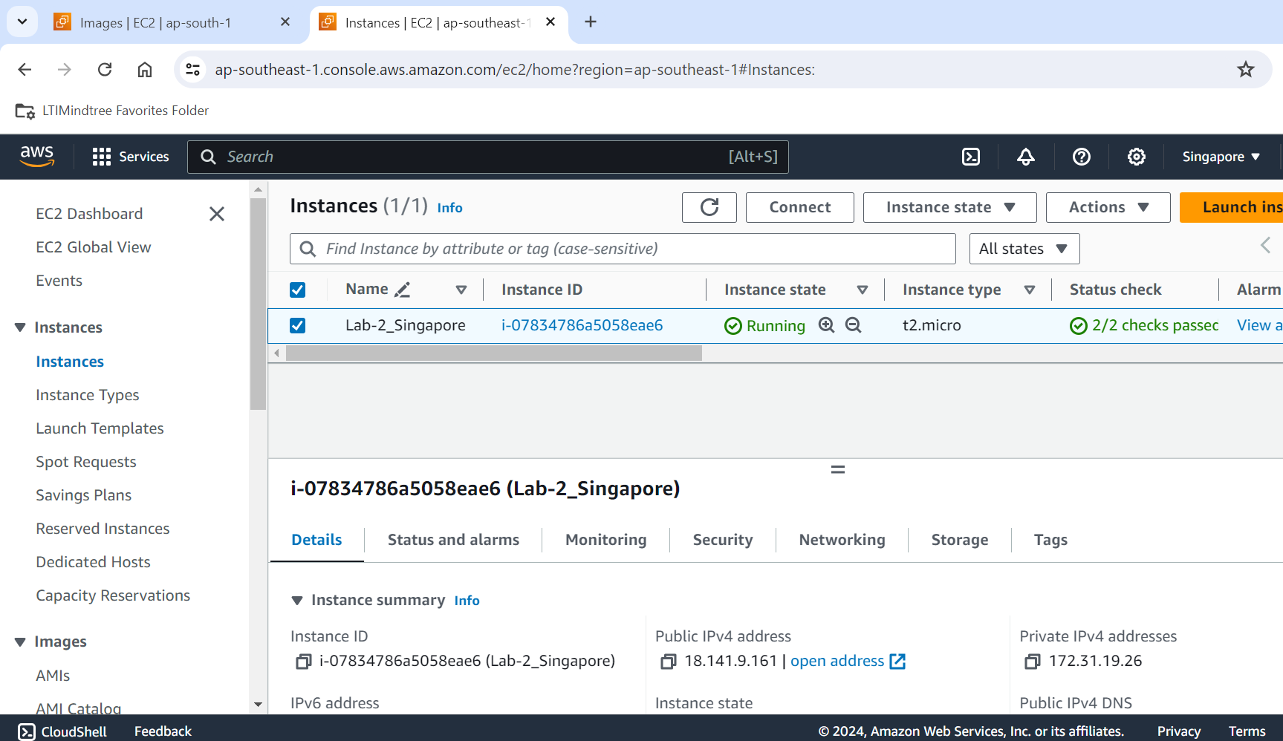

Instance has been created from the AMI in the Singapore region.

Web server is successfully running the Singapore region.